**FORENOTES**

**DON’T RESOLVE COMMENTS!**

DON’T RESOLVE COMMENTS! Resolving a comment hides it!

**PROPOSAL**

**Intro**

Since the other BG series Liches seemingly have no phylactery to destroy, and the ones that do are in the vast minority to my recollection, implementing this has these main options:

-PC Liches are special in that they have indestructible phylacteries with no extra hassle. I assume the PC liches auto-revive after 8 hours of sleep. (In 3.5, Liches rejuvenate d10 days after death at their phylacteries.) The mod [Protagonist Can Die](https://github.com/Endarire/Protagonist-Can-Die-Mod-for-EET) (<https://github.com/Endarire/Protagonist-Can-Die-Mod-for-EET>) circumvents the main character’s death auto-ending the game, and is useful as a base at least. (The [OlvynSpell](https://forums.beamdog.com/discussion/76732/v2-2-0-olvynspells-151-new-spells-for-bg-ee-bg2-ee-iwd-ee-and-eet/p1) *Contingent Resurrection* also has this functionality and may work better than Protagonist Can Die.)  
  
According to Roxanne, if the Protagonist Can Die mod is installed and seemingly isn’t working, use the console command

C:GetGlobal("K#DISABLE_PC_CAN_DIE","GLOBAL")   
  
If it is at 1, then you may die.  
  
Lore-wise, remember the Bhaalspawn party members of Imoen and Sarevok can die without the game ending. Lichdom normally doesn’t require a would-be Lich to die. Regardless, lore justifications for lichdom for the party and Bhaalspawn are secondary and *optional* to me.

-Optionally, each time a PC Lich is auto-revived, his phylactery has a chance to be destroyed. (Perhaps it's a 1% chance the first time which increases by 1-2% each time with a cap of, say, 50% that the phylactery is destroyed, but can be remade.)

-PC Liches can be revived, but their phylacteries must be brought to a specific location.

-PC Liches auto-revive where their phylacteries are. A phylactery in the party inventory means the PC just revives beside the person holding the phylactery in inventory. A phylactery in the world (on the ground or in a container) means the PC revives beside that object in an available space. Just be careful of dropping phylacteries in areas that later become inaccessible, like random encounter zones.

-Something else.

As for what's involved in making a phylactery, I'm unsure what 2E rules state, but [D&D 3.5 rules](http://www.d20srd.org/srd/monsters/lich.htm) for a phylactery cost 120,000G to craft! (That's [i]super[/i] expensive, by the way!) At that price, many players expect effectively invincible phylacteries. What ingredients are involved in making BG phylacteries is up to the mod author/GM, though going for an ingredient collection route implies a quest (chain). (I made stuff for a lichdom quest below. Perhaps joining Bodhi allows for lichdom as an alternative method.)

While we're on this topic, a fitting ToB quest for Edwin could be Lichdom. He's already super-powerful, arcane-inclined, and assuming he's done his Nether Scroll quest in SoA, he could finally have the means of achieving this goal. Besides, he already has the picture for it! (This pic also works for Edwina.)

**SUGGESTED QUEST IMPLEMENTATION: INTRO**

**Quest Summary**

In Baldur’s Gate II: Shadows of Amn, the party can find a man in the [Athkatlan Grave District](https://baldursgate.fandom.com/wiki/Athkatla_Graveyard) called Gravetender Morris, who, after completing a fairly simple but likely difficult quest of killing the liches in Athkatla, offers to use the lich dust gained from the remains of these liches to transform party members into liches - for a price.

**Gravetender Morris Stats**

Model: Male Human Wizard (Dark Purple Primary, Bright Red Secondary)

Location (Shadows of Amn): Athkatla’s Graveyard District (See Below)

Location (Throne of Bhaal): Saradush (See Below)

Race & Class: Undead Human Wizard (Necromancer)20 (Lich)

High Level Abilities (HLAs): [Dragon’s Breath](https://baldursgate.fandom.com/wiki/Dragon%27s_Breath_(spell)), [Improved Alacrity](https://baldursgate.fandom.com/wiki/Improved_Alacrity), [Summon Planetar](https://baldursgate.fandom.com/wiki/Summon_Planetar)

Ability Scores: 16 STR, 20 DEX (19 base +1 Stalker Gauntlets), 16 CON (or - CON), 19 INT, 19 WIS, 17 CHA

Alignment: TN

Equipped: [Staff of Power](https://baldursgate.fandom.com/wiki/Staff_of_Power), [Amulet of Power](https://baldursgate.fandom.com/wiki/Amulet_of_Power), [Robe of Vecna](https://baldursgate.fandom.com/wiki/Robe_of_Vecna), [Cloak of Minor Arcana](https://baldursgate.fandom.com/wiki/Cloak_of_Minor_Arcana), [Ring of Protection II](https://baldursgate.fandom.com/wiki/The_Guard%27s_Ring), [Ring of Air Control](https://baldursgate.fandom.com/wiki/Ring_of_Air_Control), [Boots of Speed](https://baldursgate.fandom.com/wiki/The_Paws_of_the_Cheetah), [Stalker Gauntlets](https://baldursgate.fandom.com/wiki/Stalker_Gauntlets), [Sling of Everard +5](https://baldursgate.fandom.com/wiki/Sling_of_Everard)

Inventory: Bag of Holding, Scroll of Wish, Scroll of Horrid Wilting, Scroll of Project Image, Scroll of Simulacrum, Wand of Cloudkill, 7652G, Lich Dust. (Lich dust can’t be stolen.)

Combat Script: Gravetender Morris dislikes combat. If attacked and he survives, he simply *teleport*s away if he is in Athkatla. If in Saradush, he will stand and fight using an epic Necromancer’s combat script that also accounts for his high level abilities.

If he dies or flees from Athkatla due to hostility from the party, he still appears in Saradush (and disappears from Athkatla) and is neutral toward them, still talkative and not concerned over their previous violence.

Morris’s combat script includes using these in order:

-A *chain contingency* with 3x *horrid wilting* centered on the nearest enemy that activates when Morris sees an enemy.

-A *contingency* with *stoneskin* on him when he sees a foe, and him casting *time stop* + *improved alacrity*.

-In *time stop*, he uses *greater malison* on the nearest foe, he uses *protection from magical energy* on himself, he uses his *spell sequencer* with 3x *remove magic* on the nearest foe, he uses *chaos*, he uses *spell* *trigger* with 3x *animate dead* centered on him, he renews his *spell trigger* with 3x *dominate* then he targets the biggest threat who isn’t immune,he uses *summon planetar,* he uses *haste*, recasts *time stop*, renews his *chain contingency* with 3x *horrid wilting*, activates his Ring of Air Control for *improved invisibility*, he self-casts *true seeing*, then he casts *protection from magic weapons*, and continues casting other useful things.  
 In short, Morris is intended as a smart, difficult, and beatable opponent - if you’re prepared!

**Lich Dust Description**

Image: Either a bag (that contains dust) or a scattering of dust

Text: This gathering of dust is seemingly all that remains of a powerful Undead spellcaster known as a Lich.

**Lich Dust Notes**

This item is added to the inventory of every [lich](https://baldursgate.fandom.com/wiki/Lich) and [demilich](https://baldursgate.fandom.com/wiki/Lich) in the game, named and unnamed. (Yes, even the weak ‘lich’ Nevaziah.) Lich dust can’t be stolen from these foes but it can be taken after these creatures die.

**Lichdom Stats**  
-The subject becomes Undead, becoming immune to the harmful effects of negative energy (at least if this is standardized so all Undead are affected the same way). They’re immune to level drain.

+2 INT, WIS, and CHA. If other Undead in BG lose their CON score, so do liches. Otherwise, the CON score is the same.

+3 bonus (or is it -3 bonus?) to natural AC.

-Immunity to mundane (that is, nonmagical) weapons.

+50% damage reduction to slashing and piercing weapons.

-Immunity to harmful spells of levels 1-5.

-Immunity to hostile polymorph effects, hostile [Mind-Affecting] effects, poison, paralysis, death effects, and fatigue/exhaustion.

-Immunity to electricity.

-Continual *see invisibility*.

-A lich gains a paralyzing touch as a melee weapon. Any non-immune creature hit with this touch that fails a save vs. death with a -2 penalty becomes permanently paralyzed. (Implementation-wise, this could be done by adding an innate ability as a toggle for paralyzing touch to be used instead of a typical melee weapon if another melee weapon is equipped.)

-A lich who dies is revived immediately after 8 hours of rest at full HP.

**Lichdom & Phylacteries**  
At present, I’d prefer not to require inventory space for this. Just assume that a PC lich simply revives where they are with all their stuff equipped after 8 hours of rest, and that phylacteries can’t be stolen/lost/damaged/destroyed.

**SUGGESTED QUEST IMPLEMENTATION:**

**JOURNAL ENTRIES**

**Son of a Lich: The First Price**

Talk with Gravetender Morris, and, if you agree to the possibility of being shunned by your deity and losing your power for becoming Undead, talk further with Morros. Look for him in [Athkatla’s Graveyard District OR Saradush].

**Son of a Lich: The Second Price**

Bring lich dust from at least 3 liches or demiliches in any combination to Gravetender Morris. Look for him in [Athkatla’s Graveyard District OR Saradush].

**Son of a Lich: The Third Price**

Bring 40,000 gold per person to Gravetender Morris for the lichdom ritual. Look for him in [Athkatla’s Graveyard District OR Saradush].

**Son of a Lich: The Fourth Price**

If you still intend for your companions or you to become a lich, seek out Gravetender Morris and talk with him. Look for him in [Athkatla’s Graveyard District OR Saradush].

**Son of a Lich: The Fifth Price**

<The party member whose name underwent the lichdom ritual> has paid the fifth and final price to become a lich as aided by Gravetender Morris.

**Murdering Morris in Athkatla**

You have slain Gravetender Morris in Athkatla. Congratulations. Do you feel better?

**[IF THE PARTY HAS TALKED WITH MORRIS IN ATHKATLA] Morris: Reunion in Saradush**

You have found Morris the Gravetender in Saradush. He seemingly wanted to know what you have been doing since last you two met.

**Murdering Morris in Saradush**

You have slain Gravetender Morris in Saradush. Congratulations. Do you feel better?

**SUGGESTED QUEST IMPLEMENTATION:**

**DIALOG FROM GRAVETENDER MORRIS**

**Dialog Option for Player**

Response from NPC

**Dialog Submenu for Player: Replaces Previous Layer of Dialog   
 Choices**

Response from NPC

**[If These Conditions Are Met] Dialog Option for Player**

NPC’s Response

**Initial Introduction (Shadows of Amn)**

*<You see a man in ornate robes whose every motion seems intentional, calm, and slow. His voice seems wise with a tone that reminds you of Gorion’s voice, but with more cracks and spoken more slowly. He smells clean despite his nearness to the dead His demeanor is of one of great importance who seems to be in absolutely no hurry.>*

“Ah, there you are. I am Morris, and you are one of many people to have been curious about me.”

**I am curious. Who are you?**

“Morris, a gravetender,” he says, grateful that you asked.

**Why are you here among the dead?**

He says with a plain smile, “I have chosen to keep the dead - and the Undead - that should not be in the city out of it. I ensure those who bring their dead here or who mourn for their dead here head in the right direction.”

**What do you think about death?**

“Death,” he says, seemingly with a quiet sigh, “is a transition from this state called ‘life’ to another called ‘death.’ Some are able to call things beyond death back to life, and all are able to put that which can die to death.”

**Then are you fond of death?**

He blinks and stares at you blankly. “I have devoted my life to the understanding of death. I believe all life wishes to live forever, to expand in this reality, to -dominate- this reality, but is cursed with this -interruption- called ‘death.’ And so I found a way to solve death.”

**Do you mean -undeath?-**

“Yes,” he says with a blank smile, “since you insisted. It is a way to accomplish -more- in life with less chance of this irksome -interruption.- I am willing to share it - for a price.”

**What sort of price?**

He clearly and eagerly smiles at a pace that is fast for him. “The first price is your peace. Are you at peace with your god? Many would disdain such a transformation, and I shall not be held accountable should your ‘transgressions’ result in harm toward you. Merely considering this option without pursuing it should not count as a stain upon your soul.”

**I am willing. Proceed!**

He silently nods at you. “The second price is understanding. Go find 3 liches or demiliches in any combination, slay them, and bring their lich dust to me. We shall talk further then.” Morris promptly stands up straight and looks you very intently in the eyes.

*<Start quest Son of a Lich.>*

**Perhaps later.**

“Ah,” he says with a long sigh. “So be it. Talk with me should your decision change. I have… long enough.”

**[IF THE GROUP HASN’T ALREADY PURCHASED AT LEAST ONE LICHDOM RITUAL] If you’re a necromancer, does that also make you Undead?**

Morris raises his eyebrows at you. “I leave -that-... to your imagination.”

**[IF THE GROUP HAS ALREADY PURCHASED AT LEAST ONE LICHDOM RITUAL] If you’re a necromancer, does that also make you Undead?**

Morris slowly smirks, as if to avoid cracking his face. “The lichdom ritual I performed for you was the same one I did on myself, many years ago.”

**Why did you become Undead?**

Morris smirks more widely. “It was likely the same reason as you: Death was an inconvenient -interruption- and lichdom provided -power- that I desired. I paid the prices you paid.”

**Any regrets about becoming Undead?**

The smirk on Morris’s face turns to a frown. “I… have learned Undeath can be a curse that overwhelms one in regret. There are too many things I wish I had not done in pursuit of lichdom. I have since learned the necessity of forgiveness and its power to unburden me from guilt, regret, shame, and the like.”

**What sorts of things did you regret?**

Morris sighs, trying not to frown. “I leave -that- to your imagination, lest I remember them too well.”

**[IF TALKING WITH MORRIS IN ATHKATLA] What do you think about killing the Undead here and looting these tombs?**

Morris sighs and shrugs. “Destroyed Undead do not enter the rest of the city. You have helped me do my job.”

**[IF TALKING WITH MORRIS IN SARADUSH WHEN IT’S UNDER SIEGE] What do you think about this city being under siege?**

Morris shrugs. “I will leave it by some means when the time is right.”

**[IF THE GROUP HAS AT LEAST 3 UNITS OF LICH DUST IN THEIR INVENTORY] Your deed is done and these liches are slain. Here’s your lich dust. Now what?**

“Good, good!” he says, with his eyes glowing and his face shining despite his slow movements. He takes the lich dust from you slowly, almost dramatically slowly, as he inspects it. “I knew each of them well. Now, they can die the -true- death.”

*<The party loses 3 units of Lich Dust*.>

**Wait! Did you -make- these liches?**

Morris looks at you with a face that bespeaks only hints of indifference with strong, confident beratement. “I will not say. Those that I knew, I knew. Those I knew not, I never knew. You completed this task for an -unrelated- reason.”

**-True death?- Does that make you a… Dustman?**

Morris smirks at you - slowly. “I pledged my allegiance to them… once. I handled enough of their dead and beings that -should- have been dead to… question… their understanding of death. They were -obsessed- with death, but afraid to pursue undeath to stop death for themselves. I… quietly left in disagreement to focus on my own… pursuits.”

**What did you mean when you said the second price was understanding?**

Morris smiles and nods at you, slowly. “You will be like them - potent, Undead, alive - but -you-,” he says, staring at you as if staring directly into your soul, “will be -unlike- them: -You- will -live!-” He reaches his hand toward your shoulder. “You -know- what these liches can do. -You- will be better!”

**How will I be better?**

Morris looks at you blankly, and blinks. “They are destroyed. You are not. You won.”

**Answer my previous question. What happens next?**

“The third price is money,” he says, slowly holding out his hand. Lichdom is inherently expensive in costly ritual components. That is why not every caster of weak or great power becomes one.” He raises his eyebrows at you. “Each recipient of this ritual will require 120,000 gold.”

**That’s your price for EACH!? That’s ridiculously high!**

“-That- is the third price. Pay it… or not.” Morris looks at you smiling, almost grinning.

**When should I pay you?**

He leans in his head slightly toward you. “When you are ready, talk to me.”

**[IF THE GROUP HAS MET OR TALKED WITH BODHI OR/AND ANY OF HER VAMPIRIC AGENTS] What do you think of the Undead creatures roaming the streets of Athkatla at night?**

“I am not with them,” he says nonchalantly, “and I am not against them.” He looks you clearly in the eyes, “We have… an understanding.”

**[IF THE GROUP IS ON THE BALDUR’S GATE II CHAPTER 6 QUEST TO SLAY BODHI IN HER LAIR] I am about to slay this vampiric Bodhi. What do you say to this?**

Morris simply shrugs.

**[IF THE PARTY HAS GIVEN MORRIS THE 3 LICH DUSTS] Lichdom still interests me despite the monetary cost. Let’s deal, my friend!**

“Ah…” he says with a long, quiet exhale. “Lichdom has -quite- the monetary price, but the allure of immortality is worth it. Do you have the -entire- 120,000 gold on you now? If so, we can proceed.”

**I have reconsidered. Perhaps we shall handle this later.**

“Later is no problem for me,” he says with a coy smile. “I am in no hurry.”

**[IF THE PARTY HAS ENOUGH MONEY ON HAND FOR AT LEAST ONE LICHDOM RITUAL AND THE PARTY SIZE IS AT LEAST 2] Here is your money. Let’s do this!**

Morris looks at you eagerly. “The fourth price is decision. Who among you shall undergo this ritual? You must be a sufficiently powerful spellcaster to benefit with a caster level of at least 11, or else your time is wasted. Are you ready to begin?”

**<The player chooses a character in the active party from this list with an option to cancel. The cancel option has the response of “I have reconsidered. Perhaps we shall handle this later.”>**

*<More info below. Once the party chooses a character, Morris says gives his No/Yes decision with the text from the solo inquiry below and the party chooses. If the character is rejected from lichdom here, only the most specific message plays (like Sandrah’s message for Sandrah), and this character can’t undergo this ritual.>*

**[IF THE CHOSEN CHARACTER IS <CHARNAME> AND IRENICUS HAS <CHARNAME>’S SOUL]**

MORRIS: Your soul is not entirely with you, <CHARNAME>. I cannot proceed with the ritual this way.

**[IF THE CHOSEN CHARACTER IS <CHARNAME> AND IRENICUS DOESN’T HAVE <CHARNAME>’S SOUL]**

<If Aerie is in the party.>

AERIE: You would willingly throw your life away and become undead? I... I don’t know if I can stay if you do this!

<If [Afaaq](https://github.com/Argent77/DjinniCompanion) is in your party.>

AFAAQ: You seek immortality, <RACE>? Immortality for its own sake is misunderstood and overrated.

<If Ajantis is in the party.>

AJANTIS: What trickery is this?! I should have known all you sought was unholy power!

<If Baeloth is in the party.>

BAELOTH: <CHARNAME>, there is absolutely no shame in taking every advantage offered to you!

<If [Bodhi](https://github.com/InfinityMods/LongerRoadEE/releases) is in the party.>

BODHI: Come, join me in death!

<If Anomen is in the party.>

ANOMEN: What fellowship can darkness have with the light? One will overwhelm the other!

<If Caelar is in the party.>

CAELAR: <CHARNAME>, you would so eagerly side with the darkness and fall from the light? I thought you were wiser than that!

<If Cernd is in the party.>

CERND: <CHARNAME>, what you seek to become is... unnatural. Tread lightly lest it overtake you.

<If Corwin is in the party.>

CORWIN: You want to become a skeleton? If you get out of line, I am an -expert- in destroying your kind!

<If Edwin is in the party AND Edwin isn’t Undead.>

EDWIN: You seek the secrets to live forever in death like Szass Tam of Thay? You are a -bold- one, <CHARNAME>. Just remember how the great Edwin Odisseron helped you and reward your faithful advisor and companion with this same boon.

<If Edwin is in the party AND Edwin is Undead.>

EDWIN: Well, well, well, <CHARNAME>. You took your sweet time coming to the -right- decision of joining me in pissing in death’s face - figuratively speaking.

<If [Hull](https://docs.google.com/document/d/1wFwWwewqk6MXhs6IEMvUh1CdmhAqQUPK3d_YiosbaJY/edit) is in the party.>

HULL: Kid, you’re -really- gonna go undead? Your excuse’ll be amusing, at least!

<If Imoen is in the party.>

IMOEN: <PRO_BROTHERSISTER>, you’re really gonna do it? I was quietly hoping you wouldn’t!

<If Irenicus is in the party.>

IRENICUS: You are the child of a god, <CHARNAME>. It is your -right- to rule!

<If Jaheira is in the party.>

JAHEIRA: <CHARNAME>, of all the things you could do for power, you would choose -this- most... unnatural solution?

<If Jan is in the party.>

JAN: <CHARNAME>, this reminds me of the time my second cousin twice removed on my mother’s side turned into a lich. The process rendered her permanently, supernaturally, irrevocably mute. It was the happiest day of our lives!

<If Keldorn is in the party.>

KELDORN: Careful, <CHARNAME>. Whatever power you seek to control -will- take its toll on your soul!

<If Mazzy is in the party.>

MAZZY: <CHARNAME>, I cannot in good conscience just let you hurl yourself into foolish danger like that!

<If Minsc is in the party.>

MINSC: Boo says undead reek of stinking evil! We would hate to kick your butt for goodness!  
  
<If [Neh’taniel](https://www.nexusmods.com/baldursgate2ee/mods/60?tab=description) in in the party.>  
NEH’TANIEL: Seeking undeath for its own sake is regrettable, <CHARNAME>.

<If Rasaad is in the party.>

RASAAD: I am deeply concerned for your well-being, <CHARNAME>. You allow temptation to taint you to the very core!

<If Sarevok is in the party.>

SAREVOK: So, <PRO_BROTHERSISTER>, you really -are- like our father in loving death!

<If Valygar is in the party.>

VALYGAR: <CHARNAME>, what you propose for yourself is of the -most foul of magics!-

<If Viconia is in the party.>

VICONIA: <CHARNAME>, be careful. There is more to this immortal, undead life than you realize. It makes you a pawn to a different set of actors.

<If Xzar is in the party AND Xzar isn’t Undead.>

XZAR: Lichdom? That sounds like the sweet, sweet embrace of death and power!  
  
--NEXT DIALOG BOX--

XZAR: STOP HOLDING OUT ON ME!

<If Xzar is in the party AND Xzar is Undead.>

XZAR: <CHARNAME>, now you can join me for eternity!

<If Yeslick is in the party.>

YESLICK: <CHARNAME>, you? Undead? Don’t make me turn ye!

**[IF THERE ARE ANY OBJECTIONS]**

**I understand your objections and have reconsidered. I’ll not undergo this lichdom ritual now.**

MORRIS: <Morris shrugs as he slowly speaks.>

--NEXT DIALOG BOX--

MORRIS: So be it, <CHARNAME>. Perhaps we shall meet again.  
  
<END DIALOG.>

**My foster father Gorion told me that the essence of dead Bhaalspawn return to Bhaal, and if Bhaal regains all of his essence, the Lord of Murder WILL return! As an unwitting Bhaalspawn, lichdom is a means to the greater good by -preventing- this evil deity from returning!**

<If Aerie is in the party.>

AERIE: I... I understand. I just... don’t like it.

<If [Afaaq](https://github.com/Argent77/DjinniCompanion) is in your party.>

AFAAQ: I... see, <CHARNAME>. Be careful with this power that you seek, for power has a way of persuading people to believe they are better off than they are.

<If Ajantis is in the party AND Keldorn isn’t in the party.>

AJANTIS: A thinly-veiled excuse for embracing the bloodthirsty taint of your heritage! I cannot allow this! <DIALOG ENDS. Ajantis leaves the party and attacks CHARNAME!>

<If Ajantis is in the party AND Keldorn is in the party.>

AJANTIS: A thinly-veiled excuse for embracing the bloodthirsty taint of your heritage! I cannot allow this!

--NEXT DIALOG BOX--

KELDORN: Patience, Ajantis, patience. I do not like the notion of a trusted companion becoming undead, but the return of an evil god is -far- more than -any- in our order can handle! If <CHARNAME>’s decision offends your sensibilities, you may leave us.  
  
--NEXT DIALOG BOX--

AJANTIS: <Ajantis sighs.>  
  
--NEXT DIALOG BOX--

AJANTIS: Wise words, sir.

<If Anomen is in the party.>

ANOMEN: It appears we are more kindred spirits than I first thought of you, <CHARNAME>. I am still uncomfortable about this.

<If Baeloth is in the party.>

BAELOTH: <CHARNAME>, you don’t wanna disappoint -daddy- now, hmm?

<If Caelar is in the party.>

CAELAR: <CHARNAME>, I cannot fully agree with your desire to seek undeath as a solution, yet I cannot argue with your logic. I shall tolerate this... for now.

<If Cernd is in the party.>

CERND: <CHARNAME>, my stance is the same: Be careful with this power, lest it overtake and taint you.

<If Corwin is in the party.>

CORWIN: Becoming a lich to stop a god from returning? <Corwin sighs.> I’ve heard crazier excuses on duty.

<If Edwin is in the party.>

EDWIN: Yes, yes, <CHARNAME>. All this talk about the ‘greater good’ is just nonsense to make the weak-willed feel better.

<If [Hull](https://docs.google.com/document/d/1wFwWwewqk6MXhs6IEMvUh1CdmhAqQUPK3d_YiosbaJY/edit) is in the party.>

HULL: Y’know kid, I asked for it.

--NEXT DIALOG BOX--

HULL: <Hull sighs.>  
  
--NEXT DIALOG BOX--

HULL: I still don’t like the notion of my childhood friend becoming a lich. I was kinda scared when I learned you were a Bhaalspawn!

--NEXT DIALOG BOX--

HULL: But if -you- die and Bhaal comes back? I don’t feel like killing the GOD of MURDER!

<If Imoen is in the party.>

IMOEN: <PRO_BROTHERSISTER>, your mind is made up. If that’s what you’re gonna do... I guess I’ll stay for now. I still think this necromantic stuff is kinda creepy.

<If [Irenicus](https://github.com/InfinityMods/LongerRoadEE/releases) is in the party.>  
IRENICUS: <CHARNAME>, it is time that you -embraced- that which is your birthright.

<If Jaheira is in the party.>

JAHEIRA: <CHARNAME>, you want to become an undead <PRO_MANWOMAN> so much? Fine. You go crazy and I’ll -gladly- kill you and stomp your phylactery to dust!

<If Jan is in the party.>

JAN: <CHARNAME>, I suppose this is a once-in-a-lifetime opportunity to definitely prove the effects of lichdom on Bhaalspawn! I promise you I won’t profit off this without your consent!

<If Keldorn is in the party.>

KELDORN: <CHARNAME>, I have generally trusted you since we met. I would hate for this apparent sacrifice of yours to cause you to lose your mind or your desire to do what is right for the sake of the world.

<If Mazzy is in the party.>

MAZZY: <CHARNAME>, perhaps I was wrong about you. Do expect me to keep a close guard on you should this power get to your overly bony head!

<If Minsc is in the party.>

MINSC: Boo says evil gods stink even more of putrid evil than an evil caster, like a diseased rat corpse that’s been in the sewer for days! Minsc will stand by <CHARNAME>’s side, for his foot is too small to kick a god’s butt to the ground!

<If [Neh’taniel](https://www.nexusmods.com/baldursgate2ee/mods/60?tab=description) is in the party.>  
NEH’TANIEL: Accepting this burden for the greater good? Now you have my attention.

<If Rasaad is in the party.>

RASAAD: So, <CHARNAME>, it seems like you want me to keep you from the temptation of this new power for the good of us all.

<If Sarevok is in the party.>

SAREVOK: <PRO_BROTHERSISTER>, you are either naive or a schemer of my caliber!

<If Valygar is in the party.>

VALYGAR: <CHARNAME>, whatever your reasoning, if you go through with this, I simply cannot stay: The tainted magic is too great!  
  
<Valygar leaves the party but drops all plot items on the ground. He refuses to rejoin the party.>

<If Viconia is in the party.>

VICONIA: <CHARNAME>, I want to believe you made the right decision.

<If Xzar is in the party AND Xzar isn’t Undead.>

XZAR: How long will you insist I live vicariously through your achievements?  
  
--NEXT DIALOG BOX--

XZAR: STOP HOLDING OUT ON ME!

<If Xzar is in the party AND Xzar is Undead.>

XZAR: <CHARNAME>, you finally decide to become my brethren!

<If Yeslick is in the party.>

YESLICK: Bah, <CHARNAME>. I’ll sod off. <Yeslick leaves the party but drops all plot items on the ground. He refuses to rejoin the party.>

**[IF THE CHOSEN CHARACTER IS AJANTIS]**

AJANTIS: I -surely- hope you jest, <CHARNAME>! I’ll not accept -any- such necromancy!

**[IF THE CHOSEN CHARACTER IS ALORA]**

ALORA: Me? A lich? I dunno. It doesn’t seem very cute!

**You’re right. Nevermind.**  
ALORA: Well, OK.  
  
--NEXT DIALOG BOX--

<Morris asks CHARNAME to choose another.>

**Think of all the treasures you could amass if you never needed to eat or breathe again!**

ALORA: That -does- sound good! I’ll do it!

**[IF THE CHOSEN CHARACTER IS BAELOTH]**

BAELOTH: You would choose -me- for this honor? I always -knew- I did well to follow you.

**[IF THE CHOSEN CHARACTER IS BODHI FROM** [**THE LONGER ROAD**](https://www.gibberlings3.net/forums/topic/32127-the-longer-road-200-combined-release-for-vanilla-and-ee-version/?tab=comments#comment-289680) **OR** [**MAZZY ROMANCE**](https://forums.beamdog.com/discussion/71473/megamod-2-45-mazzy-romance-clara-npc-darkside-anomen-flying-aerie-for-the-evil-more/p1)**]**

Morris looks at Bodhi with a tinge of regret. “I cannot do this for you, my lady, for you are already Undead.”

**[IF THE CHOSEN CHARACTER IS BRANWEN]**

BRANWEN: This sort of immortality seems fitting for a priestess of Tempus!

**[IF THE CHOSEN CHARACTER IS CAELAR]**

CAELAR: <CHARNAME>, becoming undead is beneath me. I -refuse!-

**[IF THE CHOSEN CHARACTER IS CERND]**

CERND: <CHARNAME>, what you propose is powerful, yes, but it does not sit right with my spirit. I decline your offer.

**[IF THE CHOSEN CHARACTER IS CLARA]**

CLARA: No, <CHARNAME>. No.

**[IF THE CHOSEN CHARACTER IS CORWIN]**

CORWIN: <CHARNAME>, I enjoy my own skin too much. I’m not about to risk it for this. No deal.

**[IF THE CHOSEN CHARACTER IS DORN]**

DORN: You offer me an eternal life of death and conquest? When we first met, I never -dreamed- such a proposal was within your means!

**Is that a “Thanks, yes?” or a “Thanks, no?”**  
DORN: <CHARNAME>, that is a “Thanks, yes,” if your offer is true.

**Deal.**

DORN: Then let the heavens -tremble- at our might!

**No deal. I don’t like wishy-washy.**  
DORN: <Dorn snarls at <CHARNAME>.>

**[IF THE CHOSEN CHARACTER IS EDWIN]**

EDWIN: <CHARNAME>, I am glad your superior intellect has so quickly led you to this decision. I graciously and eagerly accept my new immortal life.

**[IF THE CHOSEN CHARACTER IS ELDOTH]**

ELDOTH: <CHARNAME>, it seems you have faith in my abilities to entertain you - and help the realms - forevermore. I graciously accept this honor.  
  
--NEXT DIALOG BOX--

ELDOTH: <Eldoth bows.>

**You’re right. Nevermind.**  
ALORA: Well, OK.  
  
--NEXT DIALOG BOX--

<Morris asks CHARNAME to choose another.>

**Think of all the treasures you could amass if you never needed to eat or breathe again!**

ALORA: That -does- sound good! I’ll do it!

**[IF THE CHOSEN CHARACTER IS FALDORN]**

FALDORN: Very well. I accept.

**[IF THE CHOSEN CHARACTER IS GARRICK]**

GARRICK: Eternal life, you say? More magical power? Protection from angry mobs with torches, pitchforks, and rotten vegetables? I agree to your terms, for the show must go on!

**[IF THE CHOSEN CHARACTER IS HAER’DALIS]**

HAER’DALIS: <CHARNAME>, I have no need of undeath for immortality. My tiefling heritage already grants me that.

--NEXT DIALOG BOX--

HAER’DALIS: But my heart is eager with curiosity to be able to write about this experience and set it to the stage! For this, I accept.

**[IF THE CHOSEN CHARACTER IS** [**HULL**](https://docs.google.com/document/d/1wFwWwewqk6MXhs6IEMvUh1CdmhAqQUPK3d_YiosbaJY/edit)**]**

HULL: Kid, I just can’t do it. Maybe you can take the stain on your soul, but I’m looking forward to a peaceful afterlife, even if being turned into a bone man means I’m never hung over again.

**What about the good liches that protect the elven lands?**  
HULL: I think you know by now that I’m no elf - and if I am, let’s just treat me like I’m not.  
  
**Hull, what would persuade you to accept this gift?**  
HULL: At this point, I dunno. Likely nothing.

--NEXT DIALOG BOX--

HULL: Sure, Gorion went down like a champ protecting you, but we’ve done a -lot- to avenge him and move on!

**[IF THE CHOSEN CHARACTER IS IMOEN AND BODHI HAS IMOEN’S SOUL]**

MORRIS: <Gravetender Morris slowly and deliberately raises an eyebrow.>  
  
--NEXT DIALOG BOX--

MORRIS: Her soul is not entirely with her. I require this for the lichdom ritual.

**[IF THE CHOSEN CHARACTER IS IMOEN AND BODHI DOESN’T HAVE IMOEN’S SOUL]**

IMOEN: <PRO_BROTHERSISTER>, you want me to... do this? I could, but... this is the sorta magic Gorion warned us about.

**Gorion knew all about this and chose to die rather than use it.**  
IMOEN: Yeah, but that’s the way of the world, isn’t it? You do the best you can for the ones you love, even if it hurts.  
  
--NEXT DIALOG BOX--

**What would persuade you to accept this?**

IMOEN: I... I don’t know. It’s all creepy to me. Losing my mind to become eternal just seems wrong, y’know?

**I get it. It isn’t every day that people can choose to become undead.**  
IMOEN: Yeah. Let’s just say ‘no’ to this lich thing for me.

**I wanted to let you know that becoming a lich means you keep your mind - or it becomes even sharper! No bone puns intended.**

IMOEN: <Imoen looks uncomfortably at <CHARNAME>.>  
  
--NEXT DIALOG BOX--

IMOEN: My suspicion for the undead is showing, isn’t it? **Sis, we still lost Gorion and I don’t want to lose you. Whatever we’re facing is likely only getting more difficult from here. Accept this gift knowing you can choose to undo it one day.**

IMOEN: Well, <PRO_BROTHERSISTER>, when you put it -that- way... I’ll do it.

**[IF THE CHOSEN CHARACTER IS IRENICUS FROM** [**THE LONGER ROAD**](https://www.gibberlings3.net/forums/topic/32127-the-longer-road-200-combined-release-for-vanilla-and-ee-version/?tab=comments#comment-289680)**]**

MORRIS: <Morris turns to Irenicus.> Is this not what you wanted - your immortality returned?

--NEXT DIALOG BOX--

IRENICUS: I see you possess at least a basic repertoire of useful knowledge. This is an offer I -will- accept!

**[IF THE CHOSEN CHARACTER IS JAHEIRA]**

JAHEIRA: <CHARNAME>, I have no desire to become some undead abomination! Stop asking!

**[IF THE CHOSEN CHARACTER IS KELDORN]**

KELDORN: I must adamantly decline your offer, <CHARNAME>, for I know what my god Torm requires of me.

**[IF THE CHOSEN CHARACTER IS KHALID]**

KHALID: L-l-lichdom? Undeath? M-m-me?

**Remember what happened to Jaheira. You survived, but what if this makes the difference between life and death for someone else we care about?**  
KHALID: <Tears fall from Khalid’s face.>  
  
--NEXT DIALOG BOX--

KHALID: No! N-n-not like this! It-it is better to live pure!

**[IF THE CHOSEN CHARACTER IS KIVAN]**

KIVAN: <CHARNAME>, no. I enjoy who I am too much to trade it for -that- sort of power.

**[IF THE CHOSEN CHARACTER IS MAZZY]**

MAZZY: No. Those who wish to act like Paladins do -not- willingly become undead!

**[IF THE CHOSEN CHARACTER IS MINSC]**

MINSC: Boo is grateful that you were concerned for his safety, but Minsc has other, -secret- plans on how to live long and prosper! No boniness for us!

**[IF THE CHOSEN CHARACTER IS NEERA]**

NEERA: Now I wonder what’s better - wild magic or undeath. I -suppose- that being undead would make me immune to a -lot- more oopsies!  
  
--NEXT DIALOG BOX--

NEERA: <CHARNAME>, I think what I’m trying to say is yes. But if it hurts, expect me to scream and cry and maybe run away.

**[IF THE CHOSEN CHARACTER IS NALIA]**

NALIA: A lich? But... isn’t that disgusting, evil, and -expensive?- Wouldn’t I be a hypocrite if I did it?

**Nalia, you want to help your people. You can’t do that if you’re -dead.-**

NALIA: <Nalia sighs.>

--NEXT DIALOG BOX--

NALIA: I know.

**What do you think about living forever?**

NALIA: <Nalia sighs.>  
  
--NEXT DIALOG BOX--

NALIA: I think it’s fine until you see all your friends and loved ones die. Then what’s there to live for? Serving your people who just keep dying of old age or famine or war?

**So, what do you say?**

NALIA: <CHARNAME>, I know you’re trying to convince me, and I -know- you’re trying to be helpful, but I still say no. There are other ways to help you, help me, and help my people.

**[IF THE CHOSEN CHARACTER IS NEH’TANIEL]**

NEH’TANIEL: Lichdom only has an effect on the living. Consider this a polite refusal.

**[IF THE CHOSEN CHARACTER IS QUAYLE]**

QUAYLE: You’re giving me the chance to say outsmart death? Of COURSE I want this! Thank you!

**[IF THE CHOSEN CHARACTER IS SANDRAH FROM** [**SANDRAH SAGA**](https://baldursextendedworld.com/Sandrah/)**]**

Morris looks wide-eyed at Sandrah and says, “I… will not tamper with the dealings of Elminster and the dear family of a Chosen of Mystra. If lichdom is what you so seek, -surely- you can do so by your own means.”

**[IF THE CHOSEN CHARACTER IS SAREVOK]**

SAREVOK: <PRO_BROTHERSISTER>, you would help me regain power like the divine essence I lost? What a wise and gracious <PRO_MANWOMAN> you are!

**[IF THE CHOSEN CHARACTER IS VALYGAR]**

VALYGAR: <CHARNAME>, consider this your warning: Had I not known and respected you as I have, your proposal would have driven me to violence against you.

**[IF THE CHOSEN CHARACTER IS VICONIA]**

VICONIA: <CHARNAME>, consider me grateful for your offer, but I am torn. I -know- how my kind have treated the undead.  
  
--NEXT DIALOG BOX--

VICONIA: However, lichdom is power, and a power -worthy- of respect! If you truly mean it, <CHARNAME>, I shall -embrace- this power!

**Viconia, receive this power!**  
VICONIA: <Viconia grins a sly, determined grin!>  
  
**Your hesitation made -me- hesitate!**

VICONIA: Let me assure you, <CHARNAME>, that I -know- from -experience- what to expect, and it is a power for -me- to control!

**You seem -too- eager for this. Not yet.**  
VICONIA: <Viconia snarls at <CHARNAME>!>

**Enjoy your undeath. May it be worth it.**

VICONIA: You have my appreciation, <CHARNAME>.

**[IF THE CHOSEN CHARACTER IS XAN]**

XAN: You would consider me worthy of this? It’s better than -death-, I suppose.  
  
--NEXT DIALOG BOX--

XAN: Alright, <CHARNAME>. At least I’ll -try- to succeed as a lich.

**[IF THE CHOSEN CHARACTER IS XZAR]**

XZAR: For so long have I waited for an opportunity to embrace lichdom, my -destiny!- You have my deepest thanks from my maddened, blackened heart!

**[IF THE CHOSEN CHARACTER IS YESLICK]**

YESLICK: Is this some kinda sick joke? I turn undead. I don’t turn -into- undead!

**[IF THE CHOSEN CHARACTER IS YOSHIMO]**

Morris responds, “Yoshimo… There is… something about you that may nullify my… understanding… with your patrons. I shall not do it for that sake.”

**[IF THE CHOSEN CHARACTER IS UNDEAD LIKE** [**HEXXAT**](https://baldursgate.fandom.com/wiki/Hexxat) **OR WILL FROM** [**WILL OF THE WISPS**](https://downloads.weaselmods.net/download/will-of-the-wisps/)**]**

Morris says with a tinge of regret, “It is not my place to mettle with those who are already Undead, nor does the ritual work for them. You have your immortality. Enjoy your Undeath.”

**[IF THE CHOSEN CHARACTER IS A SINGLE, DUAL, OR MULTICLASS CASTER BUT HAS TOO LOW OF A LEVEL (THAT IS, 10 LEVELS OR LESS IN THIS CASTING CLASS)]**

Morris responds, “Ah… I see the -potential- in you for lichdom, but the -magic-, the -art- simply lacks its necessary hold on you! Another time, perhaps.”

**[IF THE CHOSEN CHARACTER ISN’T A CASTER]**

Morris responds, “You… you are no caster. Magic is not known to your innermost being. Lichdom shall elude you.”

**[IF THE PARTY HAS ENOUGH MONEY ON HAND FOR AT LEAST ONE LICHDOM RITUAL AND THE PARTY SIZE IS EXACTLY 1] Here is your money. Let’s do this!**

Morris looks at you eagerly. “The fourth price is decision. You must be a sufficiently powerful spellcaster to benefit with a caster level of at least 11, or else your time is wasted. Are you ready to begin?”

**No, actually!**

“Decide decisively then,” he says, raising his eyebrow at you. “I shall wait.”

**Yes!**

“Then the -fifth- price is trust.” He looks at you with his arms out and palms up as to signify friendship. “Do you -trust- me now to properly perform this ritual?”

**Will I lose my flesh?**

Morris slowly shakes his head as if to say “no” in an exaggerated fashion.

**How can this process be undone?**

“If it can…” Morris says, slowly training off, “…you have asked the wrong question.”

**Now that you mention it, no.**

Morris replies, “My trust awaits your trust.”

**Yes!**

*<The party loses the lichdom fee and the screen goes black. The chosen character falls to the ground.>*

“The pain was only temporary. You have survived the process.” Morris looks smugly at you. “You are now a lich by the prices you have paid.”

*<The chosen character’s alignment becomes Evil: LG or LN becomes LE, NG or TN becomes NE, and CG or CN becomes CE. The character becomes an Ex-Paladin or Ex-Ranger if he was a Paladin or Ranger respectively.>*

**[IF SOMEONE’S PHYLACTERY IS BROKEN BEYOND REPAIR] Can you fix a damaged or broken phylactery?**

MORRIS: <Gravetender Morris frowns as he quietly and slowly sighs.>  
  
--NEXT DIALOG BOX--

MORRIS: I cannot. I apologize for this. However, I can craft another one for you for the same price as the original.

**[IF THE PARTY HAS AT LEAST 1 BROKEN OR DAMAGED PHYLACTERY AND ENOUGH CASH] Please do!**

MORRIS: Whose phylactery should I replace?

**Nevermind.**

MORRIS: Acknowledged.

**<Insert list of eligible phylacteries, even if the characters aren’t in the party.>**

**[IF THE PARTY HAS AT LEAST 1 BROKEN OR DAMAGED PHYLACTERY BUT LACKS CASH] Please do!**

MORRIS: My apologies, but I require more coins to craft a new phylactery.

**[IF THE PARTY HAS NO BROKEN NOR DAMAGED PHYLACTERIES] I don’t have any broken nor damaged phylacteries at the moment. Maybe we’ll talk later about this.**  
MORRIS: <Morris slowly smiles.>  
  
--NEXT DIALOG BOX--

MORRIS: Perhaps. Perhaps.

**You foul necromancer! How dare you defile the living?!**

Morris merely sighs at you and slowly, -very- slowly, rolls his eyes at you. “I keep the dead - and the Undead - in order here. I act peaceably around you. If you incite violence against me, it is -your- fault. Do you wish to fight me now?”

**Nevermind.**

“Yes, yes,” Morris says with a slow, impatient tone. “Nevermind.”

**[IF THE PARTY IS IN ATHKATLA] We fight!**

“No,” Morris says with a sigh, “we do not.”

*<Morris casts* teleport *and doesn’t return to Athkatla.>*

**[IF THE PARTY IS IN SARADUSH] We fight!**

“For a child of the God of Murder, you seem awfully hypocritical.” Morris sighs and shakes his head, moving faster than you’ve ever seen him move. “DIE!”  
*<Combat begins!>*

**Goodbye.**

“Yes,” he says, waving slowly at you with his hand. “Goodbye. Do stay safe.”

**[IF THE PARTY HAS ALREADY TALKED WITH MORRIS IN ATHKATLA] Saradush Introduction (Throne of Bhaal)**

*<You see a man who looks familiar to you. His name soon comes to mind - Morris the Gravetender - and you last met him in Athkatla. He again seems to be in absolutely no hurry.>*

“Ah, there you are. I remember you, CHARNAME.”

*<The dialog tree is the same as in Athkatla except as noted here.>*

**What made you come here?**

“Wars and rumors of wars,” Morris says with a sly smile. “Death and destruction are at our heels, and the chance to witness death on a massive scale seemed like too rare of an opportunity nowadays.”

**Where do you plan to go next?**

“Wherever my whims carry me - most likely to another warzone, for war never changes,” Morris says with a sly smile. “But you, CHARNAME, are going to the Throne of Bhaal. I -sense- it. There, you will pay the fourth price - a decision - but one -far- greater than becoming a lich. I cannot say more.”

**Wait! What?**

Morris smugly smiles at you. “Reflect on what I have said, CHARNAME.“

**Thanks, I think.**

Morris kindly nods.

**[IF SOMEONE IN THE PARTY IS A LICH VIA MORRIS] I have some things to say about that lichdom ritual you performed.**

Morris raises his eyebrow at you in curiosity.

**The party picks only 1 of these responses.**

**It was absolutely worth it! Thank you!**

Morris slowly and proudly smiles at you.

**I liked being a lich, but can I return to normal now?**

Morris frowns. “This is a path you have willingly chosen. You have paid the fourth price of a decision and the fifth price of trusting me to properly perform this ritual. I will not aid you in this, nor will I stop you from obtaining this if it is what you truly want.”

**I already felt regret over becoming a lich.**

Morris sighs and looks at you, his eyes sad. “I am sorry you feel that way. Regret is a common emotion among the Undead. I recommend you counteract that for the sake of your long-term sanity, lest your mind shatter and your emotions drown you in negativity.”

**I just wanted to remind you that you did this. That’s all.**

Morris sluggishly shrugs and nods.

**Did you find anyone else to lichify after you left Athkatla?**

“No,” Morris says indifferently. “No one asked like you did.”

**[IF THE PARTY KILLED HIM IN ATHKATLA] You’re here! And alive! I thought you died!**

Morris merely slowly sighs. “I -did- die and it was by -your- influence. I offer you forgiveness for your foolishness. I have already forgiven myself for my foolishness.”

**Wait! You aren’t mad about this?**

Morris sighs and slowly chuckles. “No, no, and no. Undeath has given me a new perspective: I would rather not hold onto regret the rest of eternity. I advise you do the same.”

**How did you survive?**

Morris slowly snickers. “My phylactery is positioned -far- from here, and I regenerated and restocked in my safe place.”

**I killed you once and I’ll do it again!**

Morris shrugs and sighs. “If I live, I win. If I die, I win. I have planned for these possibilities. You… seemingly have not. Will you still test my immortal patience?”

**Since you don’t seem threatened at all by this, then we won’t fight.**

Morris nods and slowly says, “That was a -wise- decision.”

**Die! Again!**

Morris sighs as the air around him fills quickly and heavily with magical energy!

**I accept your forgiveness. Thanks.**

Morris nods. <Return to the previous dialog menu.>

**[IF THE PARTY HASN’T ALREADY TALKED WITH MORRIS IN ATHKATLA] Saradush Introduction (Throne of Bhaal)**

*<You see a man in ornate robes whose every motion seems intentional, calm, and slow. His voice seems wise with a tone that reminds you of Gorion’s voice, but with more cracks and spoken more slowly. He smells clean despite his nearness to the dead His demeanor is of one of great importance who seems to be in absolutely no hurry.>*

“Ah, there you are. You are one of many people to have been curious about me. I am Morris, a gravetender in Athkatla and now here.”

**What made you come here?**

“Wars and rumors of wars,” Morris says with a sly smile. “Death and destruction are at our heels, and the chance to witness death on a massive scale seemed like too rare of an opportunity nowadays.”

**Where do you plan to go next?**

“Wherever my whims carry me - most likely to another warzone, for war never changes,” Morris says with a sly smile. “But you, CHARNAME, are going to the Throne of Bhaal. I -sense- it. There, you will pay the fourth price - a decision - but one -far- greater than becoming a lich. I cannot say more.”

**Wait! What?**

Morris smugly smiles at you. “Reflect on what I have said, CHARNAME.“

**Thanks, I think.**

Morris kindly nods.

**GRAVETENDER MORRIS’S SHADOWS OF AMN LOCATION:**

**ATHKATLA’S GRAVEYARD DISTRICT**

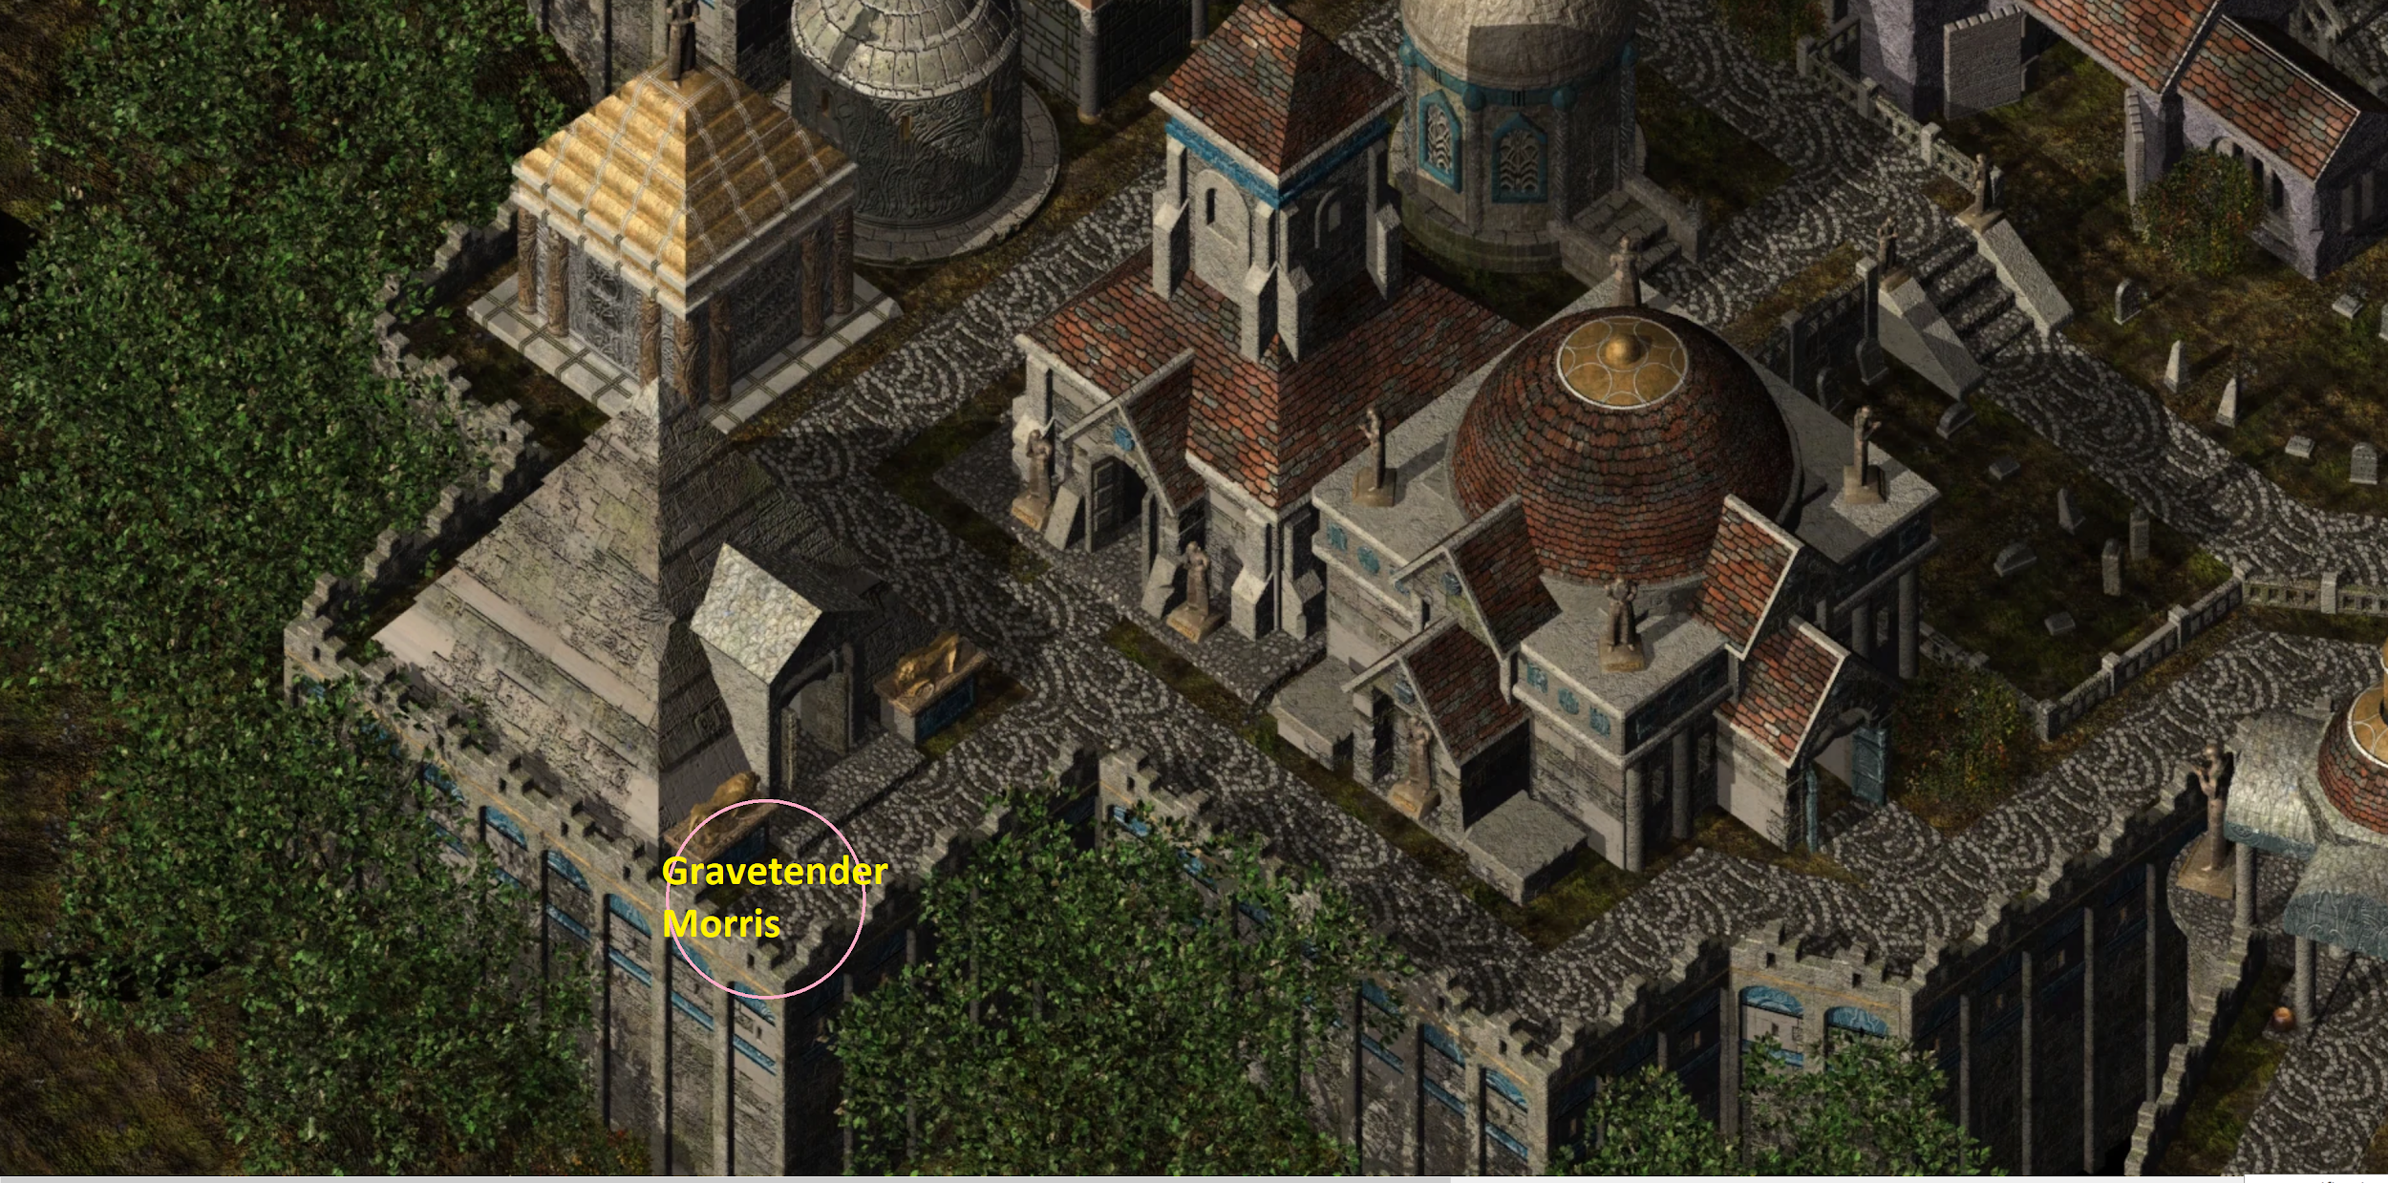

*Alternatively, he will be on this map in an easily-reached area near the southern entrance to the district.*

**GRAVETENDER MORRIS’S THRONE OF BHAAL LOCATION:**

**SARADUSH**

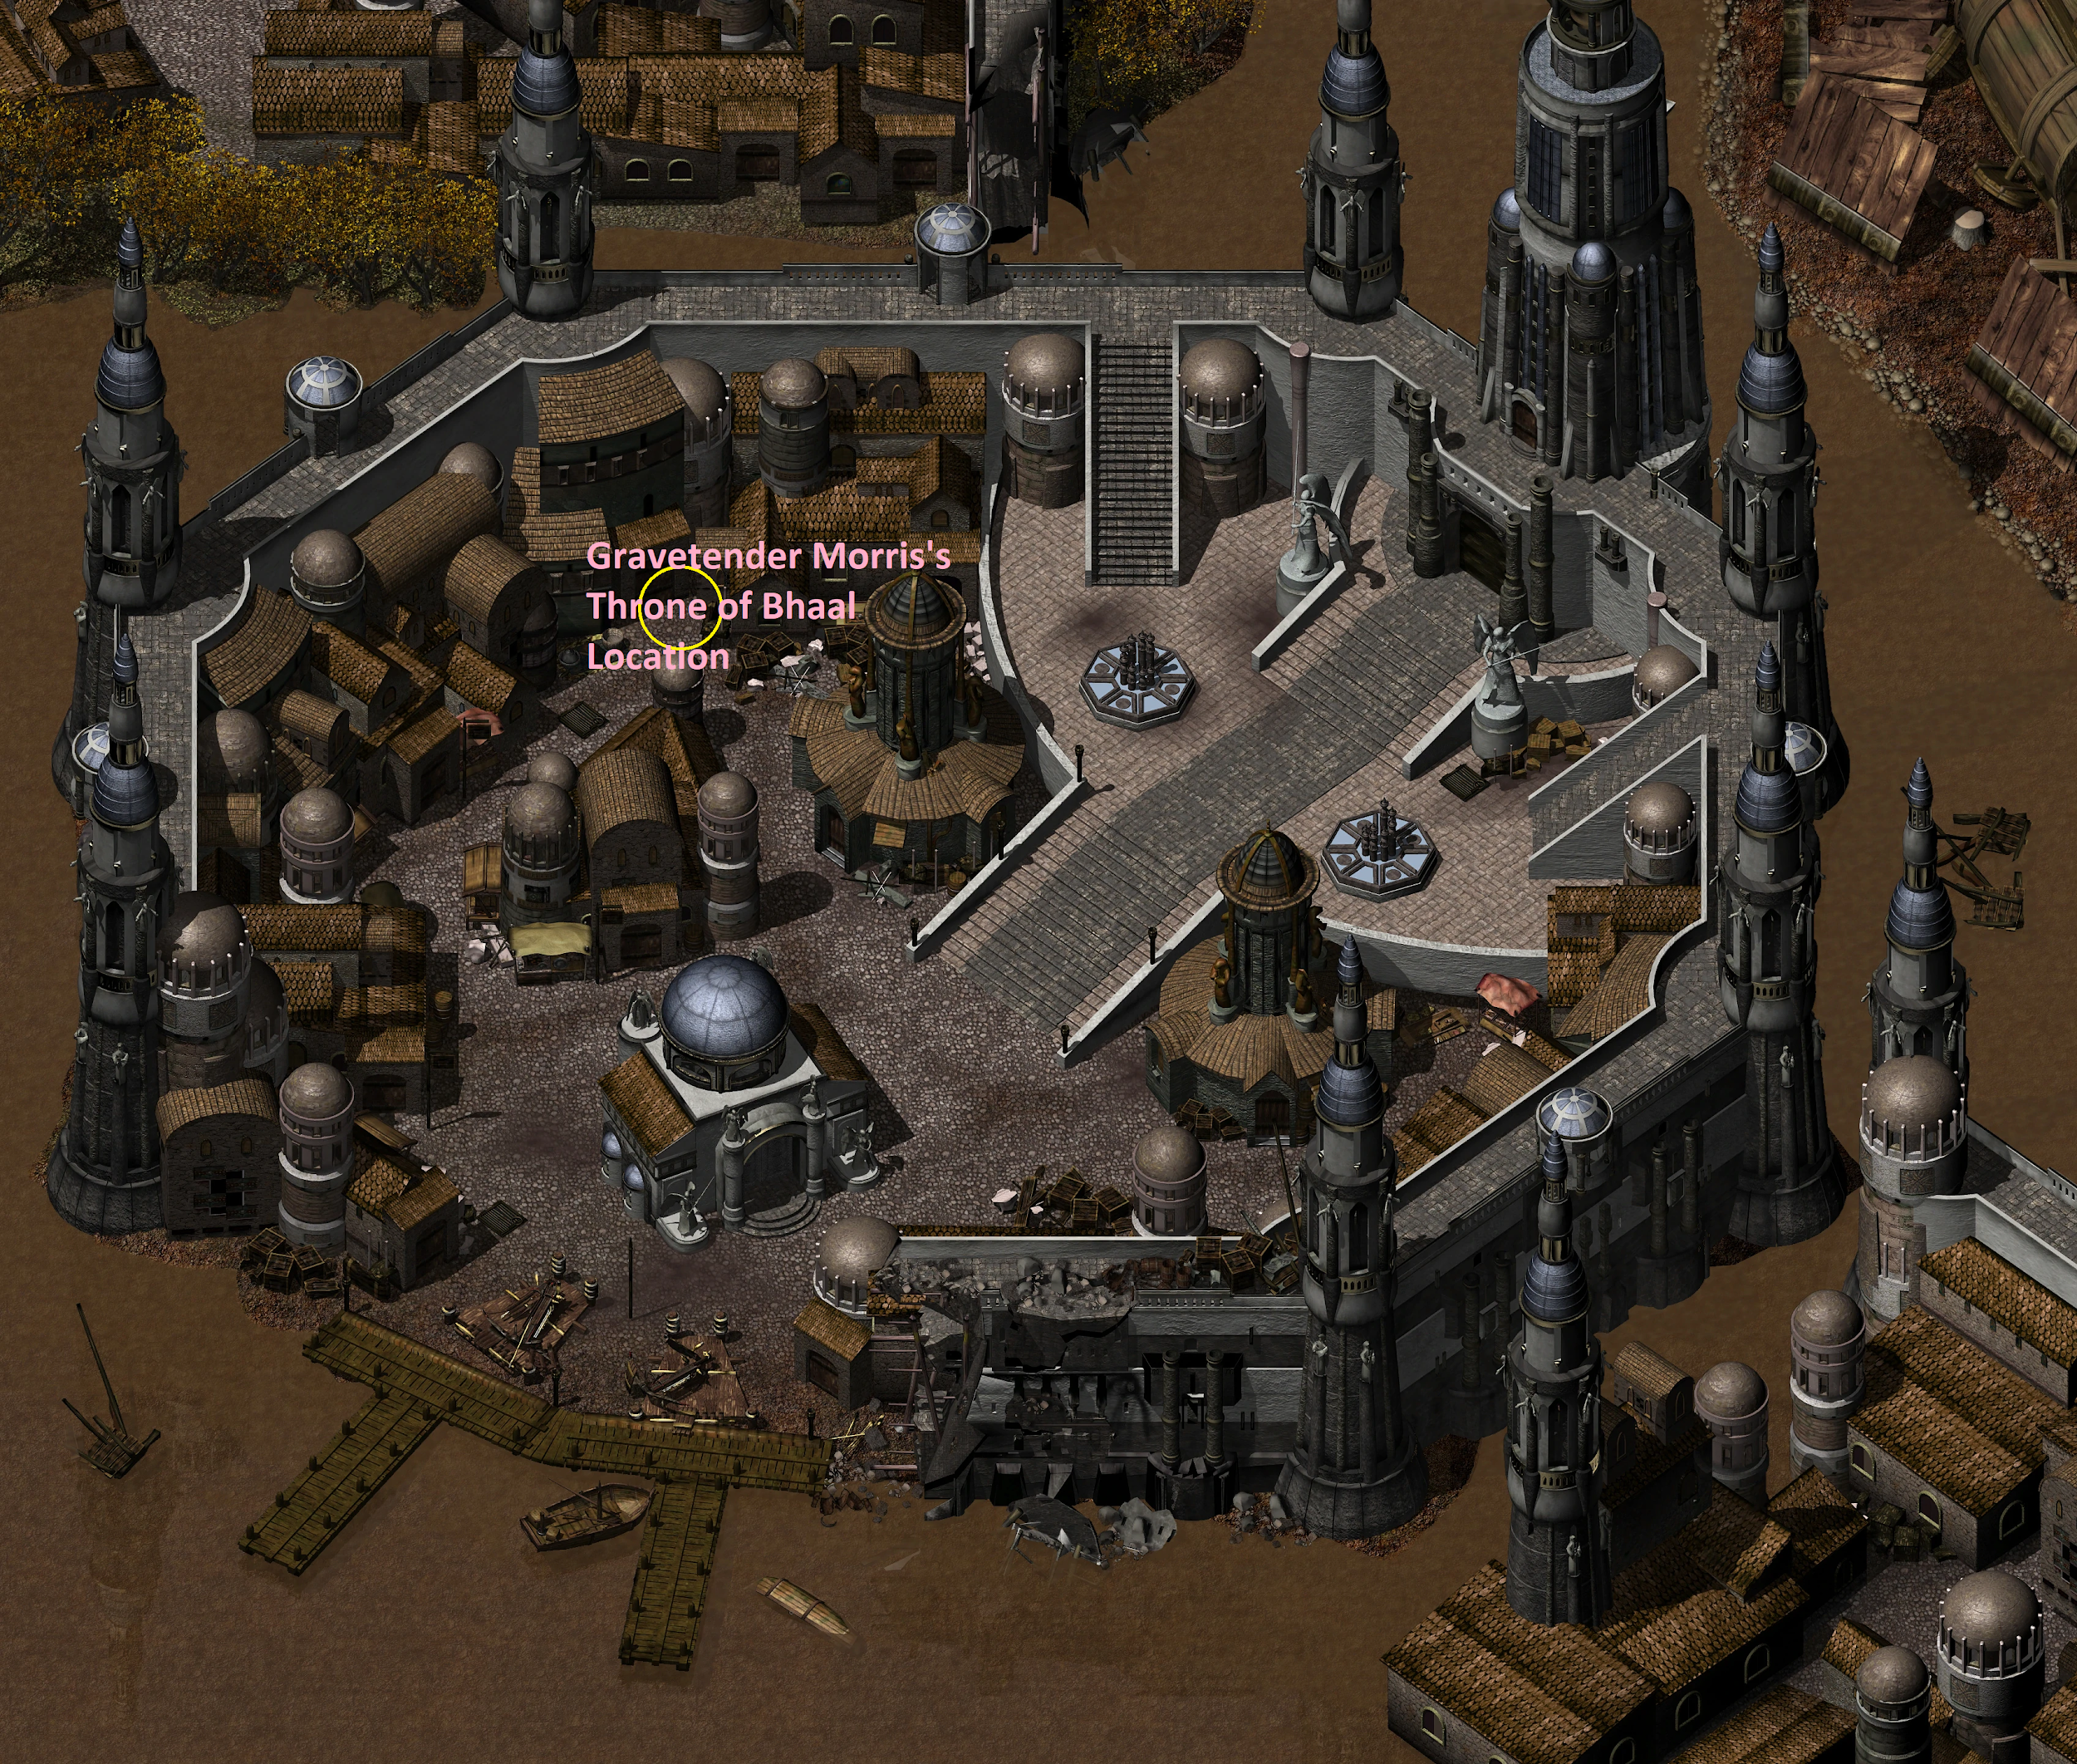

*Alternatively, he will be on this map in an easily-reached area.*

**EASTER EGG: EDWIN(A) THE LICH**

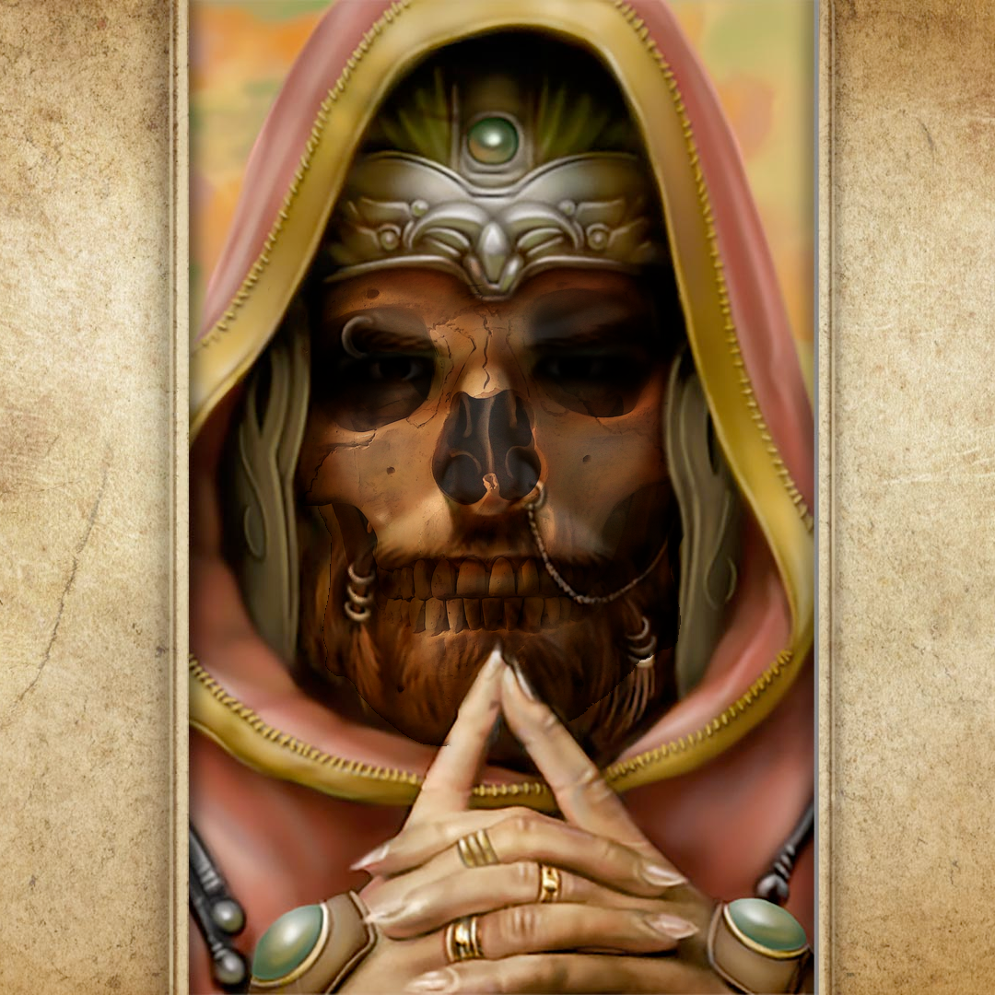

<https://i.redd.it/bz759tcs8xm41.png>

<https://www.reddit.com/r/baldursgate/comments/fjawd5/so_were_all_agreed_that_edwin_needs_to_return_as/>